**Contraception – Notes**

* **Contraceptives**: Any technique used to prevent pregnancy.
* Contraceptive methods involve one, or a combination of 2 or more, of the following:

1. Abstinence.
2. Providing a physical or chemical barrier to block the sperm from fertilising the ovum.
3. Preventing sperm or ovum production.
4. Preventing implantation after fertilisation.

Physical barriers:

Cervical cap/diaphragm:

* Cervical cap fits over the cervix to prevent sperm passage to the uterus.
* Cervical cap is more reliable if used with chemical barriers e.g., spermicides.
* Requires costly surgery to insert but easily removed.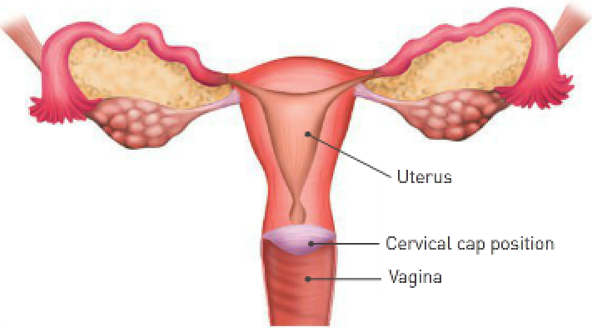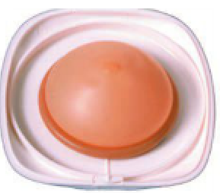

Condoms:

* Condoms are rolled over the penis to catch sperm during ejaculation.
* They help prevent STIs and are fairly cheap.
* Occasionally they can be unreliable if they slip off or break.

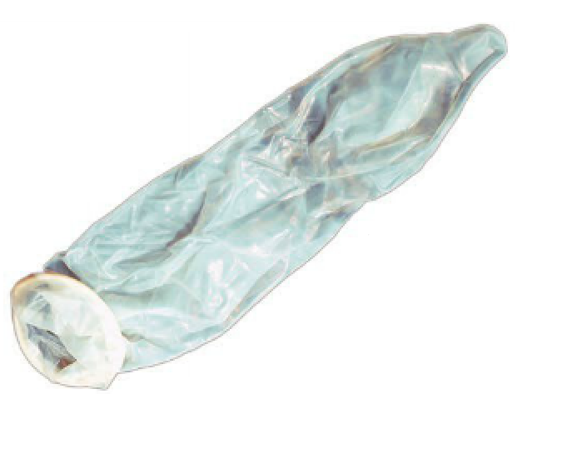

Tubal ligations (tubal occlusion):

* The menstrual and ovarian cycles continue, and the endocrine isn’t affected.
* Very reliable and sometimes reversible.
* Requires costly operation.

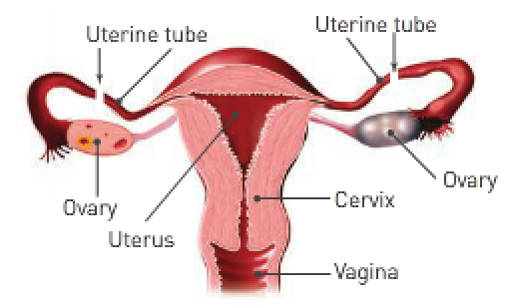

Vasectomy:

* Incisions in the vas deferens prevent sperm movement out of the testes.
* Cut ends are tied or sealed with heat.
* Ejaculation of fluid still occurs, and hormone levels aren’t affected.
* Very reliable and reversible.
* Requires costly surgery.

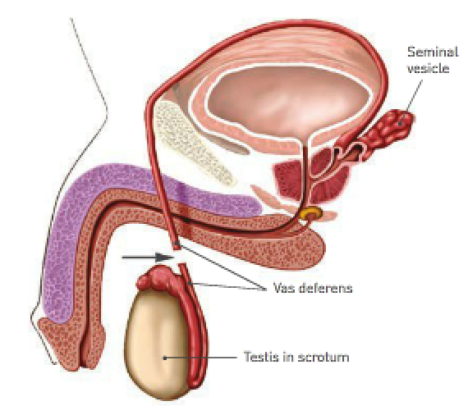

Femidom:

* Put into the vagina prior to intercourse.
* It’s around 7 inches and made of polyurethane.
* Provides an impenetrable block to sperm movement.
* Not as effective at preventing STIs as condoms.
* Moderately reliable.

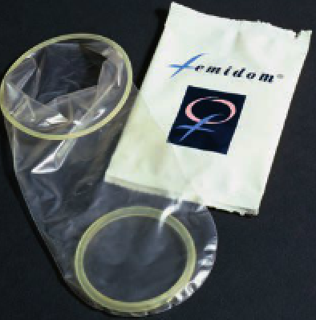

Chemical barriers:

* Birth control pill – 2 types: 1. Oestrogen-based.

2. Progesterone-based.

* Oestrogen-based prevents ovulation.
* Progesterone-based helps form a mucus plug at the cervix to stop sperm.
* Very reliable, improves acne and lessens menstrual cramps.
* Side effects: – Increased blood pressure.
* Nausea.
* Weight gain.
* Increased chance of stroke or blood clots.
* Decreased amount of breast milk.
* Can be injected to provide contraception for several (around 5) months.

Spermicides:

* Spermicides are chemicals that kill sperm.
* They come in jelly, foam or tablet form.
* Spermicides can also create hostile mucus around the cervix to block the sperm.
* They aren’t very reliable and for this reason should be used with other forms of contraceptive.
* Can be used with the condom, diaphragm and cervical cap.
* They work in 2 ways:

1. They contain a substance that immobilises and destroys sperm.
2. They react with moisture in the vagina to form bubbles of CO2 which present a physical barrier to the sperm.

Physical barriers to implantation:

Intrauterine device (IUD):

* A device containing hormones which is surgically inserted into the uterus.
* Hormones alter the endometrial lining to prevent implantation after fertilisation.
* The device itself also prevents implantation.
* Very reliable (1% get pregnant by this method).
* Heavy bleeding and cramping during menstruation often occurs.

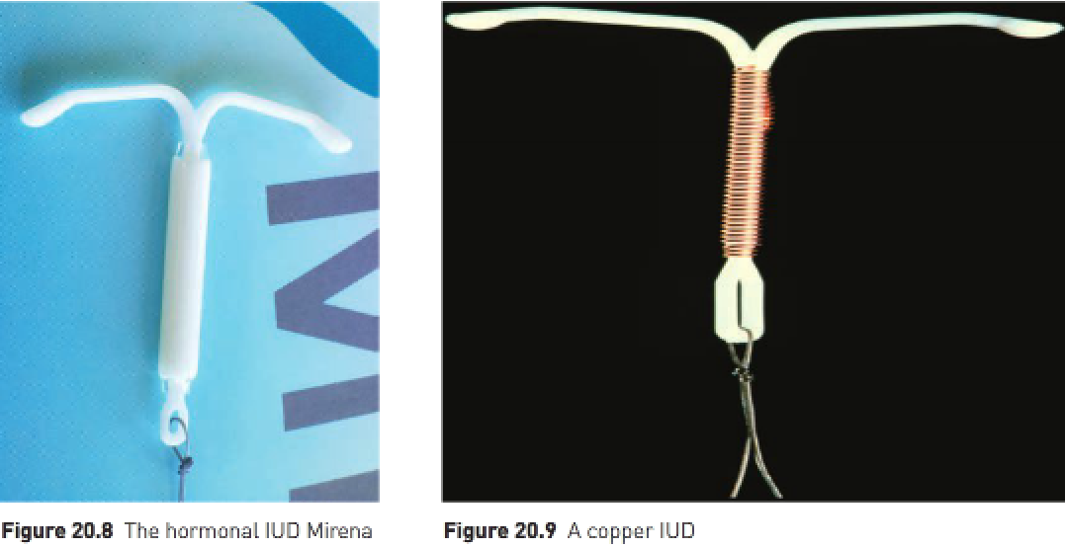

Natural methods:

* Douching – Washing out the vagina.
* Coitus interruptus – Male withdraws penis before ejaculation.
* Rhythm method – The monitoring of temperature, vaginal secretions and/or mucous to determine a “safe” period when an ovum isn’t available to be fertilised.
* These methods are highly unreliable.

Methods of contraception:

* Detection of ovulation:
* Requires the female to determine the time of ovulation so she can abstain from sexual intercourse on days when fertilisation is most likely.
* This is known as periodic abstinence (“safe period” technique).

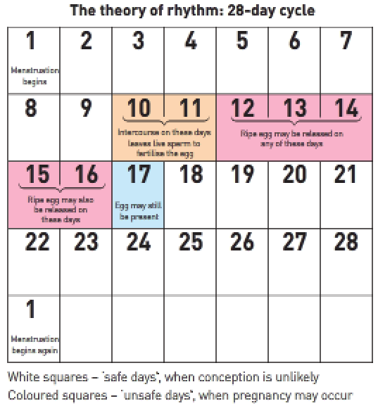

1. Rhythm method:

* An egg is available for fertilisation during a period of 3-5 days in each menstrual cycle.
* In a regular 28-day menstrual cycle, ovulation is likely to occur on day 14.
* The egg can only survive for 2 days unless it’s fertilised and sperm can survive in the female reproductive tract for 4 days at most. Therefore sexual intercourse shouldn’t occur between 4 days before and 4 days after ovulation.

1. Temperature method:

* The female takes her body temperature each morning to determine the time of ovulation more accurately.
* Ovulation is accompanied by a sharp drop in body temperature and then a rise.
* The woman can safely have intercourse 3 days after the temperature rise.

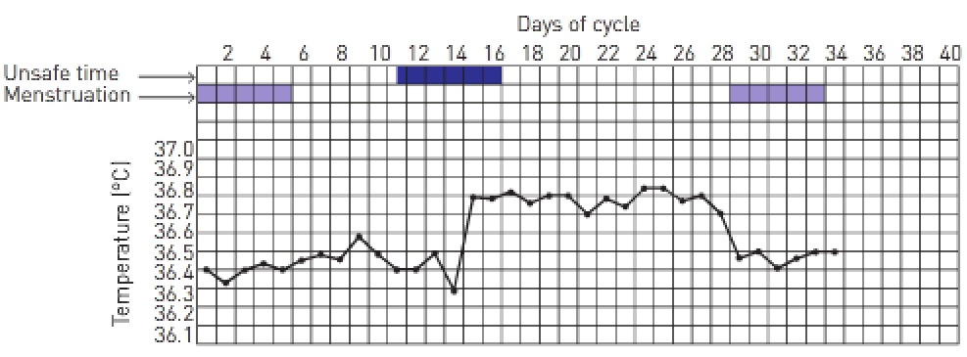

1. Mucus method:

* The woman observes change in the cervical mucus.
* Immediately after menstruation the tissues of the vaginal opening feel dry. As ovulation approaches, mucus can be detected.
* At first it’s cloudy and sticky but as the cervix secretes more mucus, it becomes clearer, feels slippery to the touch and strands will stretch without breaking.
* On the day of ovulation the peak of clear mucus is reached after which it becomes cloudy again.
* Sexual intercourse is safe when there’s no mucus and more than 3 days after the last day of the clear mucus.

1. Symptothermal method:

* A Fertility Monitor has been developed to measure daily changes in body temperature and cervical mucus.
* Lactational amenorrhoea:
* Temporary infertility that follows the birth of a child.
* Breastfeeding affects the production of hormones so that ovulation is suppressed.
* Menstrual periods mustn’t have returned, and the baby must be fully breastfed.
* Coitus interruptus:
* Removal of the penis just before the male orgasm so that ejaculation occurs outside the female vagina.
* Highly unreliable.

Hormonal contraception for women:

* Combined pill:
* Contains substances similar to progesterone and oestrogen.
* When taken daily for the first 21 days of the menstrual cycle, the substitute hormones prevent ovulation.
* Cervical mucus becomes thick and sticky, making it difficult for sperm to travel upwards from the vagina.
* “Hormones” alter the endometrium, so it becomes less receptive to implantation.
* Must be taken daily.
* Very reliable (almost 100% protection).
* Mini pill:
* Contains only the progesterone substitute.
* “Hormone” makes the cervical mucus thicker so that sperm can’t enter the uterus.
* Changes the endometrium, making it difficult for implantation.
* Must be taken daily at the same time each day.

Intrauterine devices (IUDs):

* There are 2 main types of IUDs:

1. Hormonal IUD – Made up of a plastic frame with a core that slowly releases the progesterone hormone levonorgestrel.
2. Copper IUD – Consists of a plastic frame with copper sleeves/wire around it.

* IUDs have fine nylon threads attached to their lower end so that when fitted the threads extend through the cervix into the upper vagina.
* Threads allow the woman to check it’s still in place and allows for easy removal by a doctor.
* Hormonal IUD steadily releases its hormones that makes the endometrium thin and unsuitable for implantation and stimulates the cervix to produce thick mucus which prevents sperm from entering the uterus to the egg.
* In some women, the hormone from the IUD stops ovulation altogether.
* Copper IUDs affect the movement of sperm, preventing them from moving through the uterus; they also cause changes to the endometrium to stop implantation.
* IUDs are over 99% effective, retain their effectiveness over a long period of time and are reversible.



Emergency contraception for women:

* Emergency contraceptive pill.
* Prevents or delays ovulation.
* Prevents sperm from reaching the egg.
* Prevents implantation.
* Note: Copper IUDs can be used effectively as emergency contraception.

**Castration**: Removal of the testes.

**Oophorectomy**: Removal of the ovaries.

**Hysterectomy**: Removal of the uterus.

|  |  |  |
| --- | --- | --- |
| **Method of birth control**: | **Advantages**: | **Disadvantages**: |
| **Natural methods** | No side effects.  No costs.  Acceptable to certain religious groups. | Poor reliability.  These methods provide no protection against STIs. |
| Periodic abstinence (safe period) |  |  |
| Lactational amenorrhoea |  |  |
| Withdrawal |  |  |
| **Spermicides** | Relatively easy to use. | Very unreliable on their own; need to be used in conjunction with another barrier e.g., diaphragm or cervical cap; no protection against STIs. |
| **Intrauterine devices** | Effective.  Long lasting.  Easily reversed.  Once in place can be forgotten.  In some women may be effective emergency contraception. | Must be inserted by doctor.  In some women cause pain and bleeding at menstruation.  No protection against STIs. |
| **Mechanical barriers** |  |  |
| Diaphragm and cervical cap | Doesn’t affect the menstrual cycle.  Can be used during menstruation.  Can be inserted ahead of time so that spontaneity of intercourse isn’t affected. | Difficult or unpleasant to insert.  Correct size must be prescribed by doctor.  Spermicides must be used to improve reliability. |
| Femidom | May be put into place long before intercourse.  Stronger than male condoms.  Good protection against HIV and STIs. | Placement needs practice.  More expensive than male condoms. |
| Condom | Easy to buy.  Relatively cheap.  Good protection against HIV and STIs. | May affect spontaneity.  Partners need to be motivated and cooperative. |
| **Hormonal contraception** | **for women (none of the** | **hormonal methods provide** |
| **protection against STIs** |  |  |
| Combined pill | Very reliable.  Regular periods.  Reduced incidence of ovarian and uterine cancer.  Unrelated to sexual activity. | Regular doctor’s prescription required.  Pill must be taken daily.  Possible side effects. |
| Mini pill | Reliable if taken carefully.  Suitable for women who can’t take oestrogen. | Must be taken at the same time each day. |
| Implanon | Lasts 3 years.  Relatively cheap.  Nearly 100% effective. | May cause menstrual irregularities.  Possible side effects. |
| Depo-Provera and Depo-Ralovera | Very effective.  Convenient.  Periods cease. | Injection can’t be reversed.  Delay in return to fertility when injections cease.  Possible side effects. |
| **Sterilisation – tubal ligation, Essure and vasectomy** | Permanent.  Nearly 100% effective. | Can’t be easily reversed.  Require a surgical procedure.  Specialist referral necessary for female sterilisation.  No protection against STIs. |
| **Morning-after pill** | May be useful when other methods have failed or haven’t been used.  Fairly effective.  Available over the counter. | Emergency use only.  Needs to be started within 72 hours of sexual intercourse to be effective.  No protection against STIs. |

Relative effectiveness of birth control procedures:

